January 28, 2023
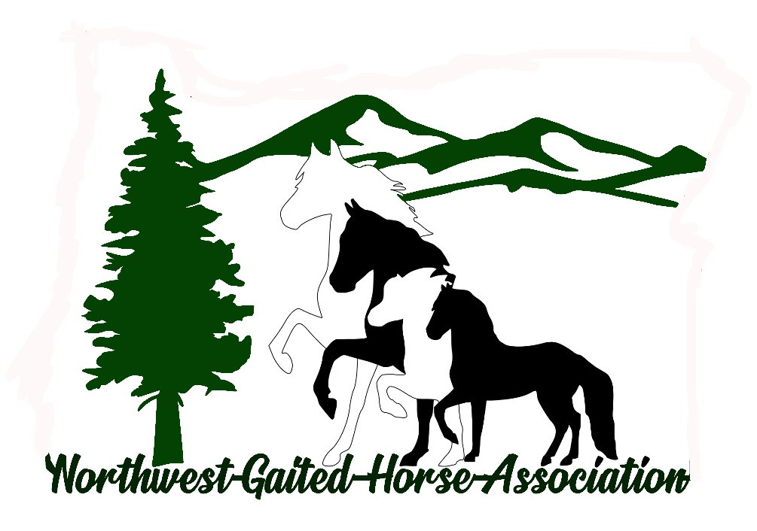
7th Annual NGWHA Meeting
With
2022 NWGHA High Point
Awards Presentation
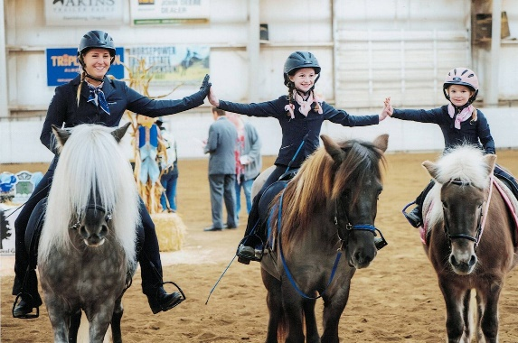
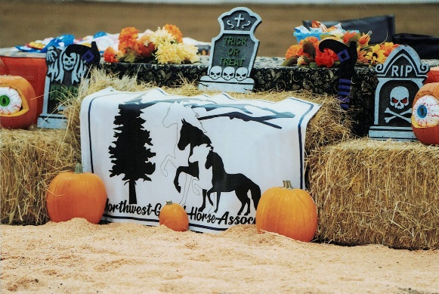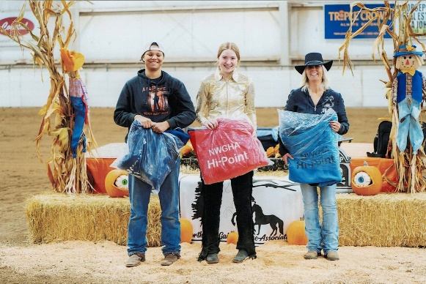
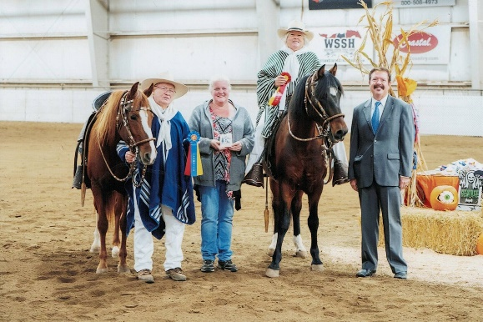
7th Annual Membership Meeting
Agenda
10:00am
Year End Comments from Board Members
And Committee Chairs
Minutes from 2022 Annual Membership Meeting
Minutes from 2022 Semi-Annual Membership Meeting
Treasurer Report
Old Business
New Business
Nominations and Election of 2023 Board
Nomination and Election of 2023 Officers
12:00 Lunch Deli Sandwiches and Green Salad
1:00 Awards Presentation

Horse Name | Owner Name | Rider Name
Model Halter
Jose's Midnight Promise | Kiah Sogard | Kiah Sogard
Bazinga | Nancy ODell | Jessica Kiser
Dakota's Blue Determination | Bobbi Chamberlain | Bobbi Chamberlain
TWH 2 Gait Amateur
Jose's Midnight Promise | Kiah Sorgard | Kiah Sorgard
I'm Totally A Princess | Chris Reznicsek | Chris Rezniscek
JFK's Jett | Lindsey R. Gross | Lindsey R. Gross
TWH 3 Gait Amateur
Dun in Ultra Gold | Nancy O'Dell | Nancy O'Dell
A Tennessee Tango | Kimberly Goodwin Helton | Kimberly Goodwin Helton
TWH Youth to Ride 2 gait
Barney Ali Oops/Major Skipper | Sarah Ness | Caroline Mottram
Dun in Ultra Gold | Nancy O'Dell | Ceanna Rodriguez
TWH 2 Gait Open
Out Till Midnight | Dan& Lillian McFarling | Lil McFarling
Confederate's Black Label | Dan& Lillian McFarling | Dan McFarling
I'm A Totally A Princess | Chris Reznicsek | Chris Reznicsek
OGB 2 Gait Youth to Ride
Barney Ali Oops/Major Skipper | Sarah Ness | Caroline Mottran
Dun in Ultra Gold | Nancy O'Dell | Ceanna Rodriguez
Chromatica/JyW Premier | Nancy Cox | Caleb Springer
SRS Sahara | Nancy Cox | Christopher Springer

OGB 2 Gait Open
Out Til Midnight | Dan& Lillian McFarling |  | Lillian McFarling
A Tennessee Tango | Kimberly Goodwin Helton |  | Kirsten Helton
Confederate's Black Label | Dan& Lillian McFarling |  | Dan McFarling
OGB 3 Gait open
A Tennessee Tango | Kimberly Goodwin Helton |  | Kirsten Helton/Kimberly
Dun In Ultra Gold | Nancy ODell |  | Nancy ODell/Brayden Fields
Major Skipper | Cheryl Morgan |  | Caroline Mottram
TWH 3 GAIT OPEN
Dun In Ultra Gold | Nancy ODell |  | Nancy ODell
A Tennessee Tango | Kimberly Goodwin Helton |  | Kirsten Helton
Major Skipper | Cheryl Morgan |  | Caroline Mottram
OGB 2 Gait 5 and Under
Nite Hawk | Nancy ODell |  | Nancy ODell
OGB 2 Gait AOT
A Tennessee Tango | Kimberly Goodwin Helton |  | Kimberly Goodwin Helton
Pusher's Ghost Buster | Kimberly Goodwin Helton |  | Kirsten Helton
Confederate's Black Label | Dan& Lillian McFarling |  | Dan McFarling
RSTD Salvador | Larry Eades |  | Larry Eades
OGB 2 Gait Novice
Skuggi Fra Friskopp | Diana Harris |  | Diana Harris
Barney Ali Oops | Sarah Ness |  | Caroline Mottram
Confederate's Black Label | Dan & Lil McFarling |  | Dan McFarling
OGB Versatility (Trail, Games, Equitation,Fun classes, Water/Wine glass)
RSTD Esteban |  | Glen Cox |  | Glen Cox
MLM Magico |  | Anne Eades |  | Anne Eades
Major Skipper |  | Cheryl Morgan |  | Caroline Mottram
RSTD Salvador |  | Larry Eades |  | Larry Eades
Trail Hours on the Trail * NWGHA Member
MLM Magico |  | Anne Eades |  | 58 hours
RSTD Salvador |  | Larry Eades |  | 31. hours
Skuggi Fra Friskopp |  | Diana Harris |  | 21 hours
Multiple Horses |  | Justine Easlon |  | 69 hours
Multiple Horses |  | Nancy Cox |  | 96 Hours
SPECIAL MVP AWARDS
Service to NWGHA
Above and Beyond
CHRIS REZNICSEK
ROGER THOMAS
SHANNON THOMAS
MEMBER VOTE for FAVORITE 2 GAIT HORSE
MEMBER VOTE for FAVORITE
ANY GAITED BREED, ANY GAIT HORSE

Participation Awards NWGHA MEMBERS
All Other Breeds (Except TWH, Peruvian and Paso Fino, Icelandic)
Nite Hawk | Walkaloosa
Handsome Zephyr | Spotted Saddle Horse
Bazinga | Walkaloosa
Peruvian Horse
MLM Magico | Anne Eades
JYW Premier | Glen Cox
RSTD Salvador | Larry Eades
Magico CR | Coral Stafford
Glamarosa De Celebrided | Nancy Cox
Icelandic Horses
Vindur | Lucy Nold
Skuggi Fra Friskopp | Diana Harris
Elskan | Sara Stewart
Safir | Sara Stewart
Vaengur | Lucy Nold
Tennessee Walking Horse
High Velocity Jazz | Shannon and Delaney Clark
WVTs Double Trouble | Lynn Hilmer
I'm 100 Proof Jose | Airisa Durand
Equalizer's Ebony Gypsy | Ruth Good &Bruce Grohn
My Some Kind of Wonderful | Kimberly Goodwin Helton

2022 NWGHA 3 SHOW OVERALL
HIGH POINT RIDER AWARDS
OPEN RIDER: JESSICA KISER
AMATEUR RIDER: KIRSTEN HELTON
YOUTH RIDER: CAROLINE MOTTRAM
NOVICE RIDER: CEANNA RODRIGUEZ

2022 GAITED HORSE
TRAINER OF THE YEAR
JESSICA KISER

